Prometheus Retreat 2022
Thursday Night Dinner Options – Dutch Treat
6:30 p.m. – Groups assemble in the hotel main lobby
Participants will be given the option to sign-up for restaurant in advance.

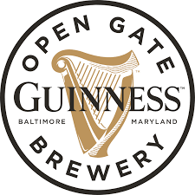

Guinness Open Gate Brewery
https://www.guinnessbrewerybaltimore.com/

Elkridge Furnace Inn
https://www.elkridgefurnaceinn.com/

George Martin’s GRILLFIRE (in the hotel)
http://georgemartinsgrillfire.com/locations/hanover-md/

